Official league roster – SOCCER 2025

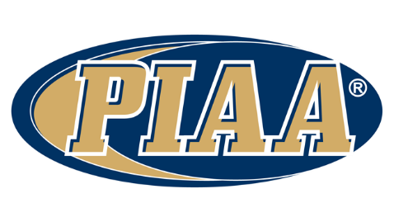

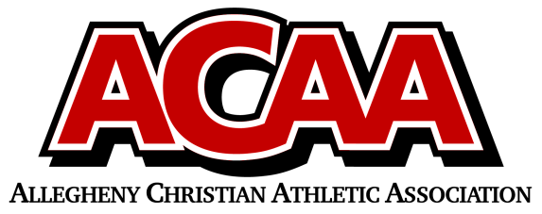

School Name: Meadowbrook Christian

Team Colors: Forest Green / White

Overall Wins ___ Losses ____ Ties ___

ACAA Wins ___ Losses ____ Ties ___ OPPONENT: __________________________

Date: _________

|  |  |  |  |  |  |
| --- | --- | --- | --- | --- | --- |
|  | **Name** | **Year** | **Position** | **Height** | **Homeschool** |
| 37 | Alex Clark | 11th |  |  |  |
| 7 | Josiah Cruz | 11th |  |  |  |
| 5 | Christian Laubach | 11th |  |  |  |
| 9 | Evan Peachey | 11th |  |  |  |
| 13 | Austin Weikel | 11th |  |  |  |
| 15 | Ike Beltz | 10th |  |  |  |
| 0/29 | Cole Blackmon | 10th |  |  |  |
| 25/00 | Malachi Dick | 10th |  |  |  |
| 8 | Ryan Eager | 10th |  |  |  |
| 33 | Everett Knopp | 10th |  |  |  |
| 2 | Keegan McCaffery | 10th |  |  |  |
| 10 | Grant Moore | 10th |  |  |  |
| 4 | Nathan Muckel | 10th |  |  |  |
| 41 | Taylor Clark | 9th |  |  |  |
| 18 | Bradyn DeWald | 9th |  |  |  |
| 12 | Luke Fasnacht | 9th |  |  |  |
| 38 | Eli Koch | 9th |  |  |  |
| 6 | Cahner O’Grady | 9th |  |  |  |
| 21 | Ray Reed | 9th |  |  |  |
|  |  |  |  |  |  |
|  |  |  |  |  |  |

VARSITY BOYS

Head Coach: Tim Clark

Asst. coach: Collin Erb

Asst. coach: Stefanie Moore

Athletic Director: Samantha Erb

Official ACAA League Team Roster. to be submitted to the scorer’s table before each game.